The Moving Coil Loudspeaker

Purpose: To study the mechanical (motional) and electrical (blocked) impedance of a moving coil loudspeaker. Additionally, we will attempt to determine the Q of the loudspeaker and examine the impedance circle near resonance for the speaker.

References:

- KFCS sections 1.7 through 1.12
- KFCS section 14.3

Apparatus:
Speaker, modeling clay
Decade resistor box
Agilent 35670A spectrum analyzer S/N__________________
Wavetek Model 29 Function Generator S/N__________________
HP467A Power Amplifier S/N__________________
SRS SR560 preamp S/N__________________
Tektronix TDS3012B oscilloscope S/N__________________

Loudspeaker Theory

Below is a modification of figure 14.3.3 on page 397 of KFCS for a moving coil loudspeaker. Note on the left is the electric signal that actually makes a coil of wire move back and forth in a permanent magnetic field. In this case we have assumed the function generator is producing a pure sine wave and that the reactance is primarily inductive due to the coil. On the right is the mechanical side of the system containing a moving mass (the speaker cone), a spring and mechanical damping. The symbols we will use in the rest of the lab are noted on this diagram. Note that the mechanical damping constant is “b” so there is no confusion with electrical resistance.
m
N
R_{E}
L_{E}
b dashpot

s spring

baffle

As a result of this model of the loudspeaker, we can write two equations using Kirchoff’s loop law and Newton’s 2nd Law as follows:
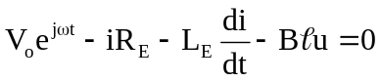
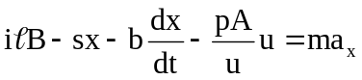

You should recognize each term in both equations. Recall that the back induced emf in the electrical equation from Faraday’s Law is Blu. The magnetic force on the moving cone mass is ilB and pA represents the force of the surrounding air pressure agitated by the speaker pushing back on the speaker cone by Newton’s 3rd Law.

These equations are coupled in that we can write them in terms of two variables current, i, and velocity on the speaker cone, u. Recall that if we assume the particular solution for both is of the form exp(jωt) , then a time derivative is multiplication by jω and integration is division by jω. We can rewrite these two equations as follows:

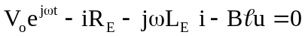
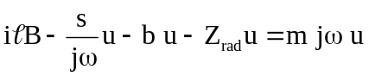
In addition to eliminating position and acceleration in favor of velocity, the second equation also introduces an impedance to the pushing back of the agitated air around the speaker. We will call this the “radiation impedance” and will define it as follows:

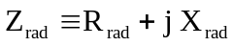

You might wonder why we just don’t lump this effect into the damping term. The answer is that we want to allow for the possibility a real and imaginary part for the agitated air. The real part is closely related to the viscosity of the air and the imaginary part is due to the fact that the air has mass that might move out of phase with the speaker’s cone. Mechanical damping is by definition is only real. Let’s further define the “radiation reactance” to be:

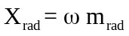

Solving for the magnetic force and then plugging in the radiation impedance leaves:

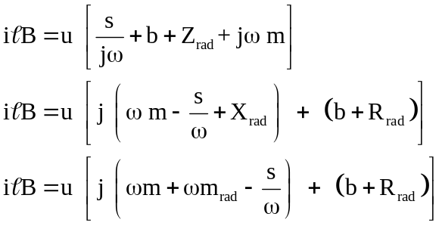

The velocity of the speaker cone is simply:

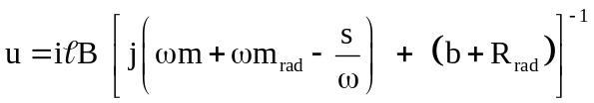

As is often the case with two coupled equations, we will substitute this result into the Kirchoff’s Law equation to eliminate the speaker cone’s velocity.

Factoring out the electrical current:

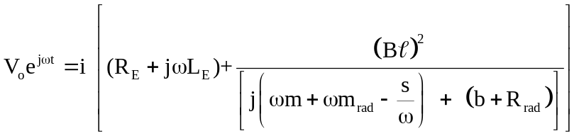

This equation provides a straight forward definition for the overall impedance of the moving coil loudspeaker.

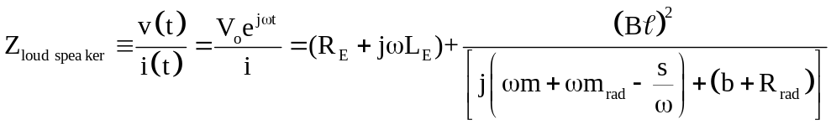

The overall impedance of the loudspeaker is then the term in the square bracket above. Although defined from the electrical perspective, it includes the mechanical components through the Faraday’s Law term (Blu) that couples the two equations. The rest of what follows is some mathematics to “clean up” the complex numbers. Generally we want to simplify so as to group real and imaginary parts of a complex expression together. That requires that we first have a real denominator in all fractions. This is accomplished by multiplying the second term by the complex conjugate of the denominator:

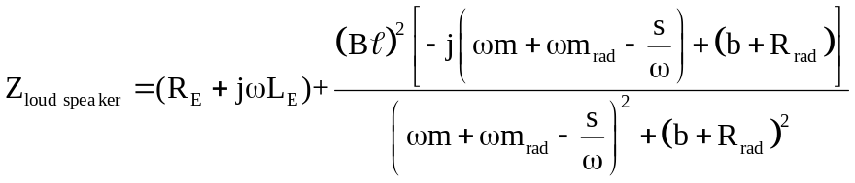

The first term (R_{E}+jωL_{E}) is called the “blocked electrical impedance.” The second term is referred to as the “motional electrical impedance”

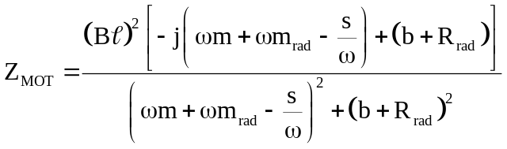

Loudspeaker engineers focus on the motional part of the overall loudspeaker impedance. They choose to model this motional impedance as a parallel RLC circuit such that:

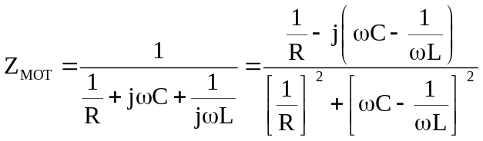

Comparing these two equations, the values of R, L, and C in the parallel circuit that models the motional impedance must be:

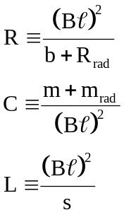

Prior to coming to lab, show by direct substitution that this is true. One of the goals of this lab is to attempt to assign values to R, C, and L in the parallel motional impedance model shown below.

C
L
N
V_{o}e ^{jωt}
V_{o}e ^{jωt}
R_{E}
R_{E}
L_{E}
L_{E}
R

Recall that the goal of getting a real denominator for a complex quantity is to separate it into real and imaginary parts. Let us call χ the real part of the motional impedance.

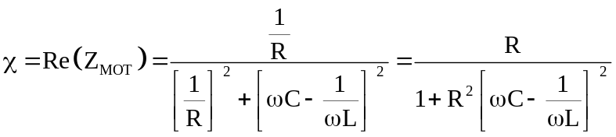

The imaginary part of the motional impedance will be called f(χ) and is equal to:

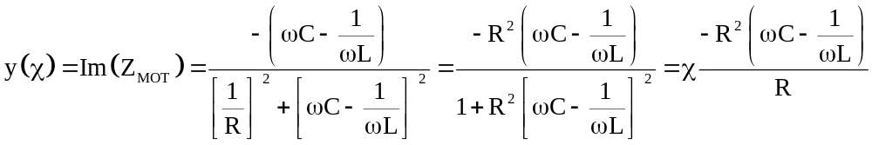

But from the real part of the motional impedance,

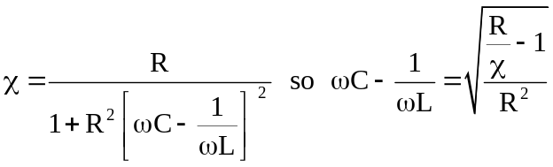

Substituting,

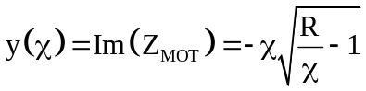
The square of the magnitude of the motional impedance is (check and see):

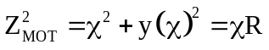

Recall that the equation for a circle centered at (x_{o},y_{o}) with radius a is:

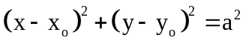

This means that if the motional impedance were plotted in the χ, y(χ) plane, it would map out a circle with its center located at (R/2,0) with a radius a = R/2. Complete the square above to show this before coming to lab on Thursday.

The impedance of the entire loudspeaker is obtained by including the blocked electrical impedance and the motional impedance:

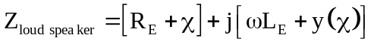

This also maps out a circle with radius a = R/2, and the center of this circle is located at (R_{E}+R/2, ωL_{E}).

This lengthy mathematics is important because the Agilent spectrum analyzer has the ability to display the real and imaginary parts of a measured quantity as you sweep through some frequencies. If you plot the real value of the loudspeaker’s impedance on the x-axis, and the imaginary value of the loudspeaker’s impedance on the y-axis,(where the angular frequency is a parametric variable) then the result will be a circle in the (Resistance - real, Reactance - imaginary) plane.

The following is a typical spectrum analyzer output as a loudspeaker passes through resonance:
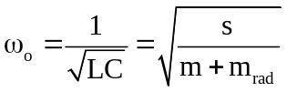
Re(Z_{loudspeaker})
Im(Z_{loudspeaker})
R_{E}
R/2
ωL_{E}
R+R_{E}
ω_{ο}
ω_{u}
ω_{l}
½ power points because Re(Z_{MOT})~R/2
Note the location and reason for the location of the resonant frequency and the upper and lower half power points. Recall that the resonance “quality factor is given by:

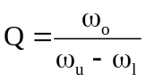

Procedure

1. Setup or verify the setup of the apparatus is as shown on the below drawing. The decade box resistance substitution box should be set to 300 Ω. The Agilent spectrum analyzer should be set to ~500 points/sweep and swept in frequency from about 10 Hz to 100 Hz. Set “measured data” for both Ch 1 and Ch 2 to display freq response 2/1.

source
ch 1
ch 2
speaker
decade box
Power amp

2. The total impedance is proportional to the ratio of the voltage across the speaker to the voltage across the decade box resistor. This is because the above wiring diagram is schematically:
V_{sweepgen}

Z _{loudspeaker}
V_{ch 2}
V_{ch 1}
Sweep generator
R_{DB}

The voltage divider rule tells us that the voltage at channel 1 is

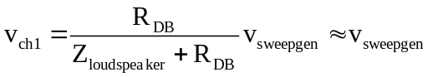

where we expect Z_{loudspeaker} << R_{DB.} Using Kirchoff’s loop rule,

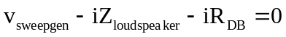

So the current is

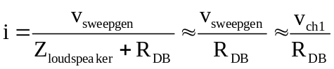

By Ohm’s Law,

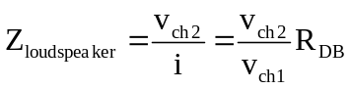

3. Split the screen into top and bottom displays using “display format” -> “upper/lower.” Select “Active Trace” -> A and “Trace Coord” -> “real part” to display the real part of the impedance in the upper display. Shift “Active Trace”-> B and “Trace Coord” -> “imag part” to display the imaginary part of the impedance in the lower display.

4. Sweep to obtain the resonance frequency, the upper and lower half power frequencies, and the corresponding reactance at these frequencies. You should sweep to find a resonant frequency around 40 Hz. Look at either the nyquist or polar plot. It should be a circle as predicted. Save both sweeps. It is probably best to return to single display format while saving the data.
You will need to make 3 plots.
a. Re(Z) vs f - pick peaks on this plot to get f_{o}
b. Im(Z) vs f - pick peaks on this plot to get f_{u} and f_{l}
c. Im(Z) vs Re(Z) – use your scale to obtain the best radius of the impedance circle
Don’t forget to multiply the Agilent real and imaginary output by 300 Ohms before you plot.

5. Add a known mass of clay (M ~ 30g) in a symmetric ring near the center of the cone. The additional mass should lower the resonant frequency. Repeat step 4 with the added clay.
Complete the following table:

ω_{o1}
ω_{u1}
ω_{l1}
Q₁
ω_{o2}
ω_{u2}
ω_{l2}
Q₂
M
a
R_{E}
L_{E}

6. From the 2 resonant frequencies obtained, we want to develop an equation for the spring constant, s, for the speaker. Let’s adopt the subscript convention 1 for no clay on the speaker and 2 for clay on the speaker.

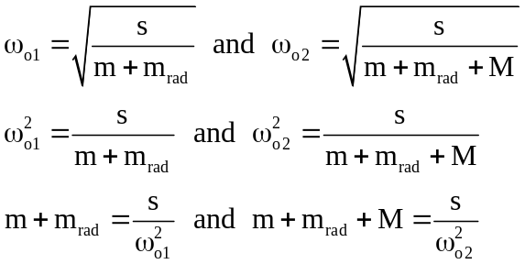

Combining these two results, the added mass of clay is

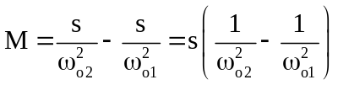

Calculate the value for the spring constant showing your calculation.

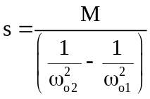

7. From the 2 resonant frequencies and the corresponding Q values, we want to develop an equation for the total mechanical damping constant for the speaker. This constant will include both the physical damping of the speaker in a vacuum and the damping added due to the surrounding air pressure.

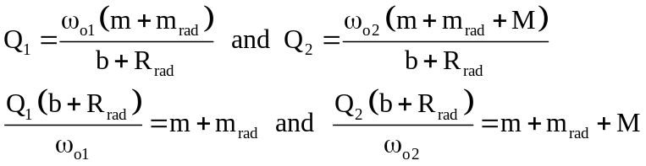

Combining these two results, the added mass of clay is

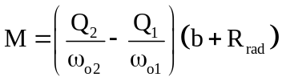

Calculate the total mechanical damping constant.

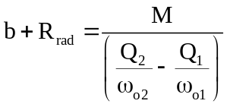

8. From the 2 resonant frequencies obtained, develop an equation for the effective mass for the speaker. This mass will include both the physical mass of the speaker cone and the mass added due to the surrounding agitated air mass (but not the mass of the clay).

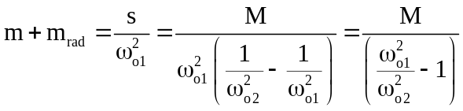
Calculate the value for the effective mass.

9. From the radius of the motional impedance circle, a = R/2, and your results from step 7, determine the resistance, R, for the parallel electric circuit model of the motional impedance. Calculate the product of the magnetic field and the length of the wire. Don’t forget to multiply the Agilent output by R_{DB} = 300 Ohm.

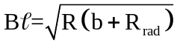

10. Using the calculated values from steps 6, 8 and 9, what are the effective inductance, L, and capacitance, C, for the speaker. Check that these values predict the correct resonant frequency for an LC circuit.

Report

1. Write an abstract for this lab.
2. Show the two steps directed in the theory section.
3. The calculations, results and conclusions are the answers to the above questions. All blocks should be filled in.
4. Attach the 6 plots directed in Procedure steps 4 and 5.

